# ***The Hindu***

# Totto-chan is still talking

[Mala Kumar](https://www.thehindu.com/profile/contributor/Mala-Kumar-1413/)

JUNE 11, 2016 16:25 IST

UPDATED: OCTOBER 18, 2016 12:50 IST

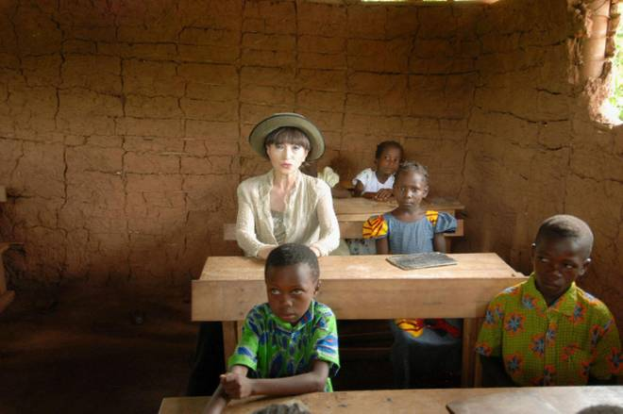

**About a wonderful school housed in train carriages and a child who grew up to become a household legend in Japan**

The debate over the nuclear strikes on Japan during World War II will probably never end. As the U.S. and Japan try to forget the past and move ahead, one place U.S. President Barack Obama could not have visited is Tomoe Gakuen. This was a [school](https://www.thehindu.com/tag/965-923/school/?utm=bodytag)founded by Sosaku Kobayashi during World War II where he taught lessons not just on science and literature, but also about nurturing relationships, making friends, and taking care of nature. This school, like many other places in Japan, was destroyed during the war in 1945, but the lessons taught there continue to inspire many.

Kobayashi was born on June 18, 1893. It is said that as a child, he would stand by the river, and pretend he was conducting an orchestra performed by the waves. No wonder he encouraged children in his school to dream, always believing in the inherent creativity and goodness in all children. The world knows about Kobayashi and his educational methods because one of his students, Tetsuko Kuroyanagi, wrote a book about her years in the school. The book was published in Japanese as Madogiwa no Totto-chan in 1981. A colleague loaned me a copy of Totto-chan: The Little Girl at the Window, the highly-acclaimed English translation by Dorothy Britton.

I have to confess I fell in love with this little girl who was fascinated by the things around her, be it a desk that could be opened and closed, or a train ticket. The other endearing characters in the book are the headmaster who encouraged free thought, and the mother who chose not to restrain the girl’s spirit.

Kuroyanagi, fondly called Totto-chan by her parents and childhood friends, is today a successful television personality whose talk show Tetsuko no Heya or Tetsuko’s Room has been aired non-stop on all weekdays since 1976! Last February, 82-year old Kuroyanagi announced, “Today is the start of the 41st (year). Please look forward to more fun talks, as I intend to continue for at least another 10 years.”

How ironic that this indefatigable talk show host was once expelled from first grade for talking too much, among her other crimes! In May 2015, the show reached its 10,000th episode, a feat recognised by the Guinness Book of World Records. It is reported that Kuroyanagi has never missed a recording and never repeated a dress on the show. But beyond this trivia is the resilience and talent of a little girl who went on to study opera singing at Tokyo College of Music, became an actor, set up the Totto-chan Foundation to professionally train deaf actors, has been the goodwill ambassador for UNICEF for over 30 years, and is an advisor to the World Wide Fund for Nature.

Kuroyanagi attributes her success to her early schooling at Tomoe, and its extraordinary headmaster, Kobayashi.

So what was so special about this school? To start with, it was a school where the classrooms were old railway carriages. It had a headmaster who, inspired by the educational methodologies of Emile Jaques-Dalcroze, who taught eurythmics in Paris, allowed children’s potential to blossom naturally. At Totto-chan’s first meeting with the headmaster, she asked him, “Tell me, are you a schoolmaster or a station master?” He answered solemnly that he was the headmaster. “I’m so glad. I have a favour to ask you. I want to come to your school,” replied Totto-chan. And she did.

In school, Totto-chan learnt to scrawl music notes on the floor, climb a tree, and help a classmate with polio climb it too. She also learnt that an old farmer could be a great gardening teacher. She narrated all the interesting things that happened to her in school to her pet dog, Rocky. Thanks to her kind, music-loving, progressive headmaster, Kobayashi, she learnt life skills easily and organically just like her classmates did.

The book has beautiful illustrations by Chihira Iwasaki. Unbelievably, the artist was not commissioned to illustrate this book. Instead, Kuroyanagi was allowed to select illustrations from the artist’s repertoire of 7,000 paintings housed in the Chihira Iwasaki Museum. Though seen by many as a children’s book, it is universal in appeal. It may reveal the child in you, and help you understand the wonderful minds of children. Written with simplicity, Kuroyanagi’s affection for the school and for the people in her young life shines through brilliantly. There is no effort to make the children cute, or to capitalise on the poignancy of war. Much of the book’s charm is in its straightforward narration, with no moralising or cloying sentiment.

In 1982, within a year of the publication of this autobiographical book in Japanese, it sold 4.5 million copies. The title in Japanese roughly translates to mean ‘to be left sitting by the window’, a phrase denoting failure in [Japan.](https://www.thehindu.com/tag/336-244/japan/?utm=bodytag)But the book records the triumph of free spirit, of innovative methods in education and the natural development of children. It also opened a window, for countless readers, to the enormous potential of sensitive schooling in the development of children. Certainly, a book worth reading, and rereading. If you can’t sit on a tree to read this book, a place by the window will do very well.

Mala Kumar writes for children and edits books for Pratham Books.